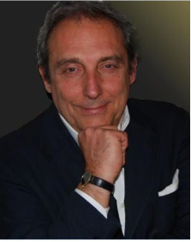
Graduated cum laude in Statistics and Economics at the University of Bologna, SDA founded Econstat after a short experience abroad.
As managing director of Econstat, he has lead more than 300 projects assigned by national and international clients and he has a broad experience in working with international organizations. He was appointed as marketing consultant for several foreign National Tourism Boards, as specialist in the identification of strategies toward the Italian market.
From 2008 to 2012 he was lecturer of “Tourism Management”, at the Faculty of Economics, LUISS University, Rome.
From 1998 to 2008 he was lecturer of “Economic and Management of accommodation enterprises” at the Faculty of Economics, University of Bologna, in Rimini.
His personal areas of expertise concerns strategic planning in tourism; tourism regional development; management of marketing initiatives (both for destinations and for private companies); conceptualization of new tourism products; market studies and research especially in the fields of customer identification/profiling and tourism trends.
He was a member of the Technical-Advisory Board of ENIT- Agenzia Nazionale del Turismo and of the Executive Board of a Regional Park (Monteveglio, Bologna). He is member of the Technical member of Bologna Welcome, the DMO of the city. Membership of Professional Bodies in the sectors of tourism and marketing, included the TRC (Tourist Research Center).
His professional activity includes publications in Italian and foreign scientific magazines (The Tourist Review, Marketing and Research Today); speeches in conferences on tourism; teaching destination marketing/management and tourism services' development in training courses addressed to public and private operators.

